Challenge Adventure Group

Ski Trip 2014: Sansicario, Italy

Dear All,
We are pleased to announce our plans for the 2014 CAG ski trip.
If you are at all interested in taking part please read on:
IMPORTANT: ACTION POINTS TO BE CARRIED OUT BY THURSDAY JAN 31st LATEST AT THE END OF THIS LETTER

General Details

Our trip operators are Halsbury Travel: www.halsbury.com. We ventured to Italy with them in 2010 and 2012, had great trips and were very impressed with their level of service, assistance, approachability etc – they are a good company in our opinion and have trust in their delivery of the trip.
They have selected a trip itinerary as follows:
Destination: | Sansicario
Date of travel: | 15/02/2014 – 23/02/2014
Length of tour: | 9 days 6 nights

What’s Included
- 6 nights full board accommodation including hot lunches
- Return Coach Transportation by Executive Coach (TV/Video or DVD/WC)
- Return Cross Channel Ferries
- Motorway Tolls and Taxes
- 6 days lift pass
- 6 x 4 hours per day of ski lessons
- 6 days ski and boot hire
- 6 days helmet hire
- Full “in house” après ski programme
- Detailed Information Pack including ski video/DVD and parents evening presentation
- Winter Sports Travel & Medical Insurance
- Piste Closure Insurance
- Ski Breakage Insurance
- An in resort representation service (Halsbury Representative)
- 24 hour emergency contact assistance from the UK

Destination & Accommodation
We will be staying in Sansicario at the Hotel Olympic Centre. Halsbury’s description of this hotel is as follows:
We are delighted to be able to offer this fabulous 3* hotel for this coming season as it was specifically built for the Olympic Games in 2006. The hotel has got 64 rooms for a total of 180 beds. Rooms can accommodate a max of 4 persons (2 single and one bunk bed), they are all en suite and have TV and telephone.
The hotels facilities include a lovely bar, a lounge, an excellent restaurant (meals are served buffet style), meeting rooms and a disco. There is also an in house ski hire shop allowing personalised fittings and corrections throughout the week.
The hotel lies at the entrance of the village, overlooking the bobsleigh rink. It’s has a doorstep ski position as you can put on your skis right outside the hotel to reach the middle station of the new gondola Cesana-Sansicario (which lies inside the bobsleigh rink). You can also ski right back to the hotel on a blue run.
There is a brand new magic carpet lift and nursery area that has just been built right outside the hotel allowing beginners skiers to now also enjoy the doorstep skiing experience.
Facilities:
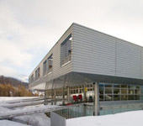 | 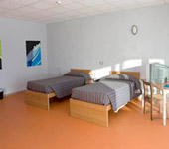 | 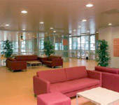 | 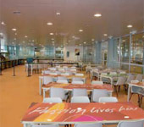
Further details about the hotel can be found here: http://www.halsburyski.com/ski/italy/sansicario

About Sansicario
Sansicario was one of the locations used in the 2006 Winter Olympics and has the following facilities:
Resort height | 1700m | Highest Lift | 2750m
Vertical drop | 1486m | Lift Capacity | 22K skiers per hour
Beginners Grade | *** | Snow making facilities | 95 snow cannons
Intermediate Grade | **** | Cross country | 10km
Advanced Grade | ** | Glacier | No
Off Piste Grade | ** | Snowboarding | Yes, all pistes
Km’s of piste | 400 | Inclusive lift pass | Yes
Slopes | - Beginner: 24  - Intermediate: 56  - Advanced: 20 | Longest Runs | 7km
Number of Lifts | 94
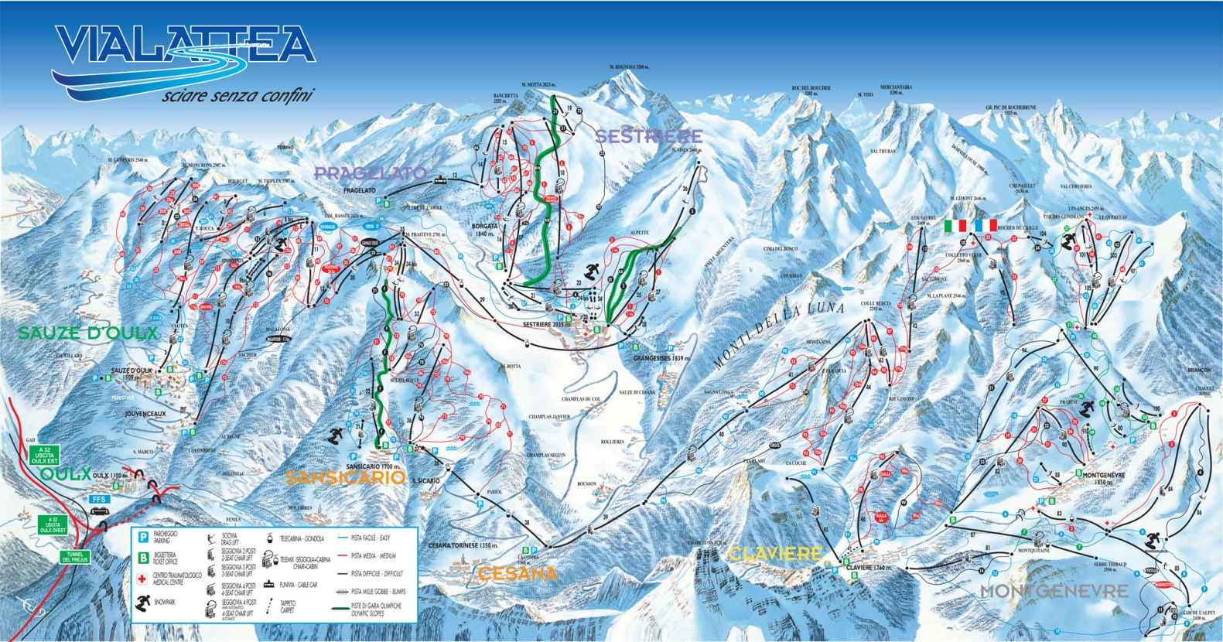
(Click the map above to see a full size version)

San Sicario is part of the Milky Way (or Via Lattea) resorts which link the old French border town of Montgenèvre with Italian ski areas including Clavière, Cesana, Sestriere and Sauze d'Oulx. Between them, they have 145 runs totalling 400km (250 miles), served by 92 lifts, plus an extensive snow-making system of 950 cannons.

The resort has something of a split personality – a traditional village linked with a purpose-built complex. The resort is ideally located to explore the Milky Way resorts in either direction. Its neighbour, Cesana Torinese, is a quaint old village, dating back to the 12th century. Sansicario was home to a number of events at the 2006 Winter Olympics, including the women's downhill.

Apres Ski Program
There are some activities to do in the hotel but optional/additional après ski activities such as bowling, ice skating, swimming etc. outside of our accommodation must be allowed for if required and as a guide allowing about £8 - £10 per evening will cover the cost of most activities. Alternatively for £25 per payer Halsbury can provide 3 x activities outside of our accommodation – we didn’t use this last time as everyone is usually pretty tired outside of the skiing activities but please make an allowance for this cost.

Costs
The trip cost is £769 for a fully inclusive trip. There isn’t any need for any extra money aside from a little spending money for hot chocolates, souvenirs / gifts and some food on the coach trips there and back. All food is included and drinks are available in the dining hall.
The schedule of payments is as follows:
- £75 – deposit on booking
- £150 – 6 weeks after booking
- £150 – mid way (around August)
- £394 (balance) beginning of December
All payments made payable to “Challenge Adventure Group”. If participants are likely to have difficulty meeting payment deadlines we have in the past been able to provide alternative payment arrangements to make it easier for members to participate. If you would like to be considered for this please contact us.

Funding
To reduce the cost, demonstrate the value of money and working as a team towards a target we are implementing a program where participants will take part in fundraising to assist in the cost of their own trips. Suggested items in this program will be bag packing at supermarkets, car washing, a jumble sale and other items. Our aim is to raise around £250 towards the cost of each participant’s trip.
The program will work as follows:
- An event will be managed / set up by a parent of a participant or a leader.
- Participants, if able, will take part the event and will then receive a proportionate amount of the proceeds from the event based on attendance.
- Each participant will then have an account which we will manage with a running total of the funds available to them towards their trip.
- At payment deadlines the full amount must be paid by a combination of either money from fund raising and / or payment by parents.
- The payment schedule requires all costs to be paid to the travel company by the middle of December. However, any events after this point will be considered a surplus to be repaid in lieu of the “loan” made by parents for the completion of the payment schedule.
- Any shortfalls in funds at payment deadlines must be met by participants own payments.
- Any surplus from fundraising will go towards CAG funds for use in other CAG trips.
This is an ambitious program and target and we will require participants and parents to be on board with commitment towards the overall goal. We understand that not all participants will be available at all the events, hence the ‘account’ management, but hope that everyone is on board in spirit if not present at particular events.
Alternatively, if you don’t wish to take part in the program and are willing to pay the full cost instead that will be fine, but we would rather have all participants involved to create a great team experience if possible.

Trip Cancellation & Booking Conditions
Whilst we don’t envisage that participants will have to cancel their participation we need to point out the conditions we have to abide by from the tour operators:
- After payment of first deposit and up until 6 weeks after date of booking: Loss of first deposit.
- Between 6 weeks after booking and up until 10 weeks before departure: Loss of 50% of invoiced price.
- Between 2 & 10 weeks before departure: Loss of 75% of invoiced price.
- Within 2 weeks of departure: Loss of 100% of invoiced price.
- Please note: If the reason for your cancellation is covered under the terms of your insurance policy, you may be able to reclaim these charges from your insurer.
All the trip booking conditions are available to view online at: http://www.halsbury.com/pdf/ski/SkiBookingConditions.pdf

Kit
Now is the best time to consider purchasing ski clothing if needed. Good deals on end of season kit are available at various retailers or online. Alternatively you can hire your kit from http://www.ski-west.co.uk/ and qualify for a discount by quoting Halsbury Travel.
If you know of anyone who has been skiing but won’t be going during that period (there will be hundreds in the Solihull area) consider borrowing or renting their gear.

Next Steps
We need to get your booking form and deposit. The booking form is available at the end of this letter. All cheques and forms need to be with us by Thursday January 31st 2014.
If you can’t make this date but would like to be considered for participation PLEASE LET US KNOW.
It is likely that planning for the funding program will start shortly. If you have ideas or areas where you can manage or assist running an event please let us know – we need all the help we can get to reach our total and have a great trip.
If you have any questions, please let us know: simon@challengeadventure.org. We look forward to seeing you in Sansicario!!
Kind Regards
Simon Thomas
Challenge Adventure


2014 Ski Trip Confirmation:
Sansicario, Italy

Your name:

Name of CAG member intending to take part in the trip:

I understand the cost of the trip will be £769 and will need to be paid according to the payment schedule shown above. I will also be willing to take part in the fundraising program.

I understand the trip will run from the dates of February 15th – 23rd 2014. I enclose the trip deposit of £75 (non-refundable) payable to “Challenge Adventure Group”.

I understand the deadline for application and payment will be Thursday January 31st 2014. If I don’t complete the payment by that date I understand my son’s place may be offered to another CAG member.

By signing this form I confirm that the above named CAG member will take part in the trip and I will be liable for the full cost of the trip, if necessary, according to the trip conditions as shown at http://www.halsbury.com/pdf/ski/SkiBookingConditions.pdf.

Signed:

Date:

Please return this form with your cheque (with the name of the participant on the back) to Chris Kehoe at 43 Tile House Green Lane, Knowle, Solihull, B93 9EZ

